Basic Acoustic Levitator

<https://github.com/penoel/Basic-Levitator>

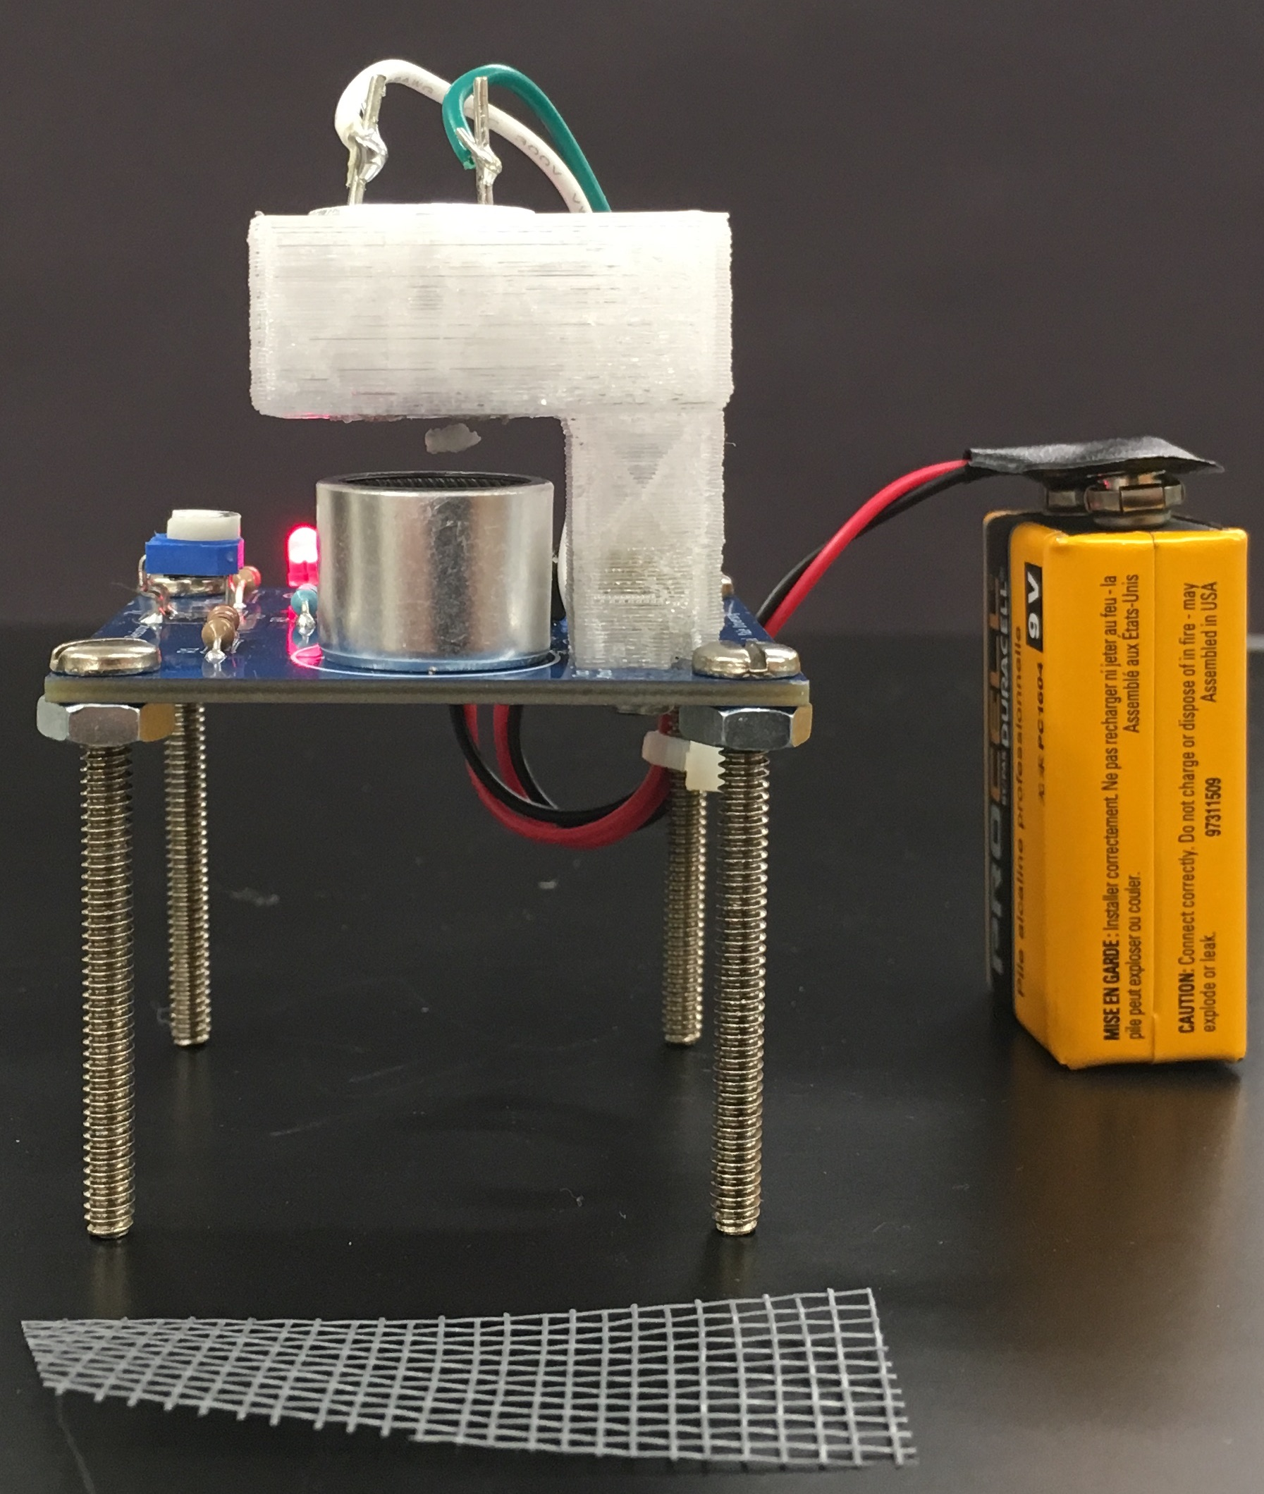

The basic levitator is a standing wave demonstration that generates an ultrasonic standing wave between two standard 40kHz distance ranging transducers. The space between the transducers is set to 1 wavelength which places a single pressure node halfway between them. This node serves as the region of stability for a small, light piece of Styrofoam. Since the air surrounding the node is moving rapidly, and creating regions of high pressure, it prevents the Styrofoam from escaping, thereby trapping it.

In this project you will be constructing your own inexpensive acoustic levitator. This will allow you to visibly illustrate one of the physical properties of sound waves that are not visible to the eye.

The heart of the levitator is the pair of transducers. Transducers very similar to this are often used in many motion and distance ranging applications. This is due to their properties of being above the range of human hearing and having little dispersion. This circuit drives the transducers at resonance with a 555 timer. A variable resistor (potentiometer) permits the frequency to be precisely tuned in to the optimal frequency to create a strong standing wave.

The Basic Acoustic Levitator kit contains the following components:

* 1 – Prefabbed printed circuit board (PCB)
* 1 – 555 Timer Microchip
* 1 – 8 Pin Chip Socket
* 1 – 10k Resistor (RB)
* 1 – 2k Potentiometer (RB+)
* 1 – 0.001 F Capacitors (C)
* 1 – 0.01 F Capacitors (C1)
* 1 – 3mm LED
* 1 – Threaded Heat Insert
* 2 – Transducers
* 1 – 22 Resistor (R1)
* 2 – 1k Resistors (RA, R2)
* 2 – Wires (red and black) (TOP)
* 1 – 9V Battery Snap (9V)
* 1 – 10 F Capacitors (C3)
* 1 – 3d Printed Part
* 1 – M3 Screw
* 1 – Screen

Solder the components onto the PCB as indicated. Please note the following cautions:

* The LEDs should be installed so the low voltage side (usually the shorter leg) is closer to the line drawn on the PCB.
* Solder the resistors and capacitor in their designated spots
* Solder in the chip socket holder so the notch is lined up with the notch on the silk screen image
* Install the 555 timer in the socket so the notch is aligned with the notch of the socket
* Solder the transducer so the leg with a black ring around it is in the + hole
* Solder the wires in the top holes on the PCB and to the other transducer
* Solder the 9V pigtail noting the polarity
* Place the 3D printed part with the small hole facing up and place the threaded heat insert in it (small diameter side against the plastic)
* Heat the insert with a soldering iron tip and push it STRAIGHT DOWN, melting into place so that it is flush with the surface.
* Screw the 3D part to the PCB

**Note**: The manufacturer seems to almost randomly label the legs, so if your device does not work switch the wires on the top transducer. An additional 14.7k is provided because some capacitor values vary due to tolerance and require a different resistor to get the same time constant. If you are having trouble tuning it and have access to an oscilloscope replace the resistor and check the frequency (should be around 40kHz).

**Levitator operation**

Connect the battery to the device. Break up the Styrofoam block into small pieces. Place one of the Styrofoam balls on the piece of screen and slide it between the transducers. Move it up and down slowly while simultaneously adjusting the potentiometer. When the resonant frequency is tuned in the ball will float. If the ball does not float after a few passes try another smaller piece. Once tuned in, you should not need to adjust the potentiometer again.

**Hints**: Secure the board before the first use. Do not use in rooms or areas with large air currents. Thin Styrofoam pieces work the best.

This device constantly draws power, whether you can see anything or not. Make sure you disconnect the battery when not in use or the battery will drain in a few hours.

**Electronics Parts Vendors to obtain additional components**

* Mouser Electronics (<http://www.mouser.com>)
* Digikey (<http://www.digikey.com>)
* Newark Electronics (<http://www.newark.com>)
* Alibaba, Aliexpress, and TaoBao

**CIRCUIT DIAGRAM FOR BASIC ACOUSTIC LEVITATOR**

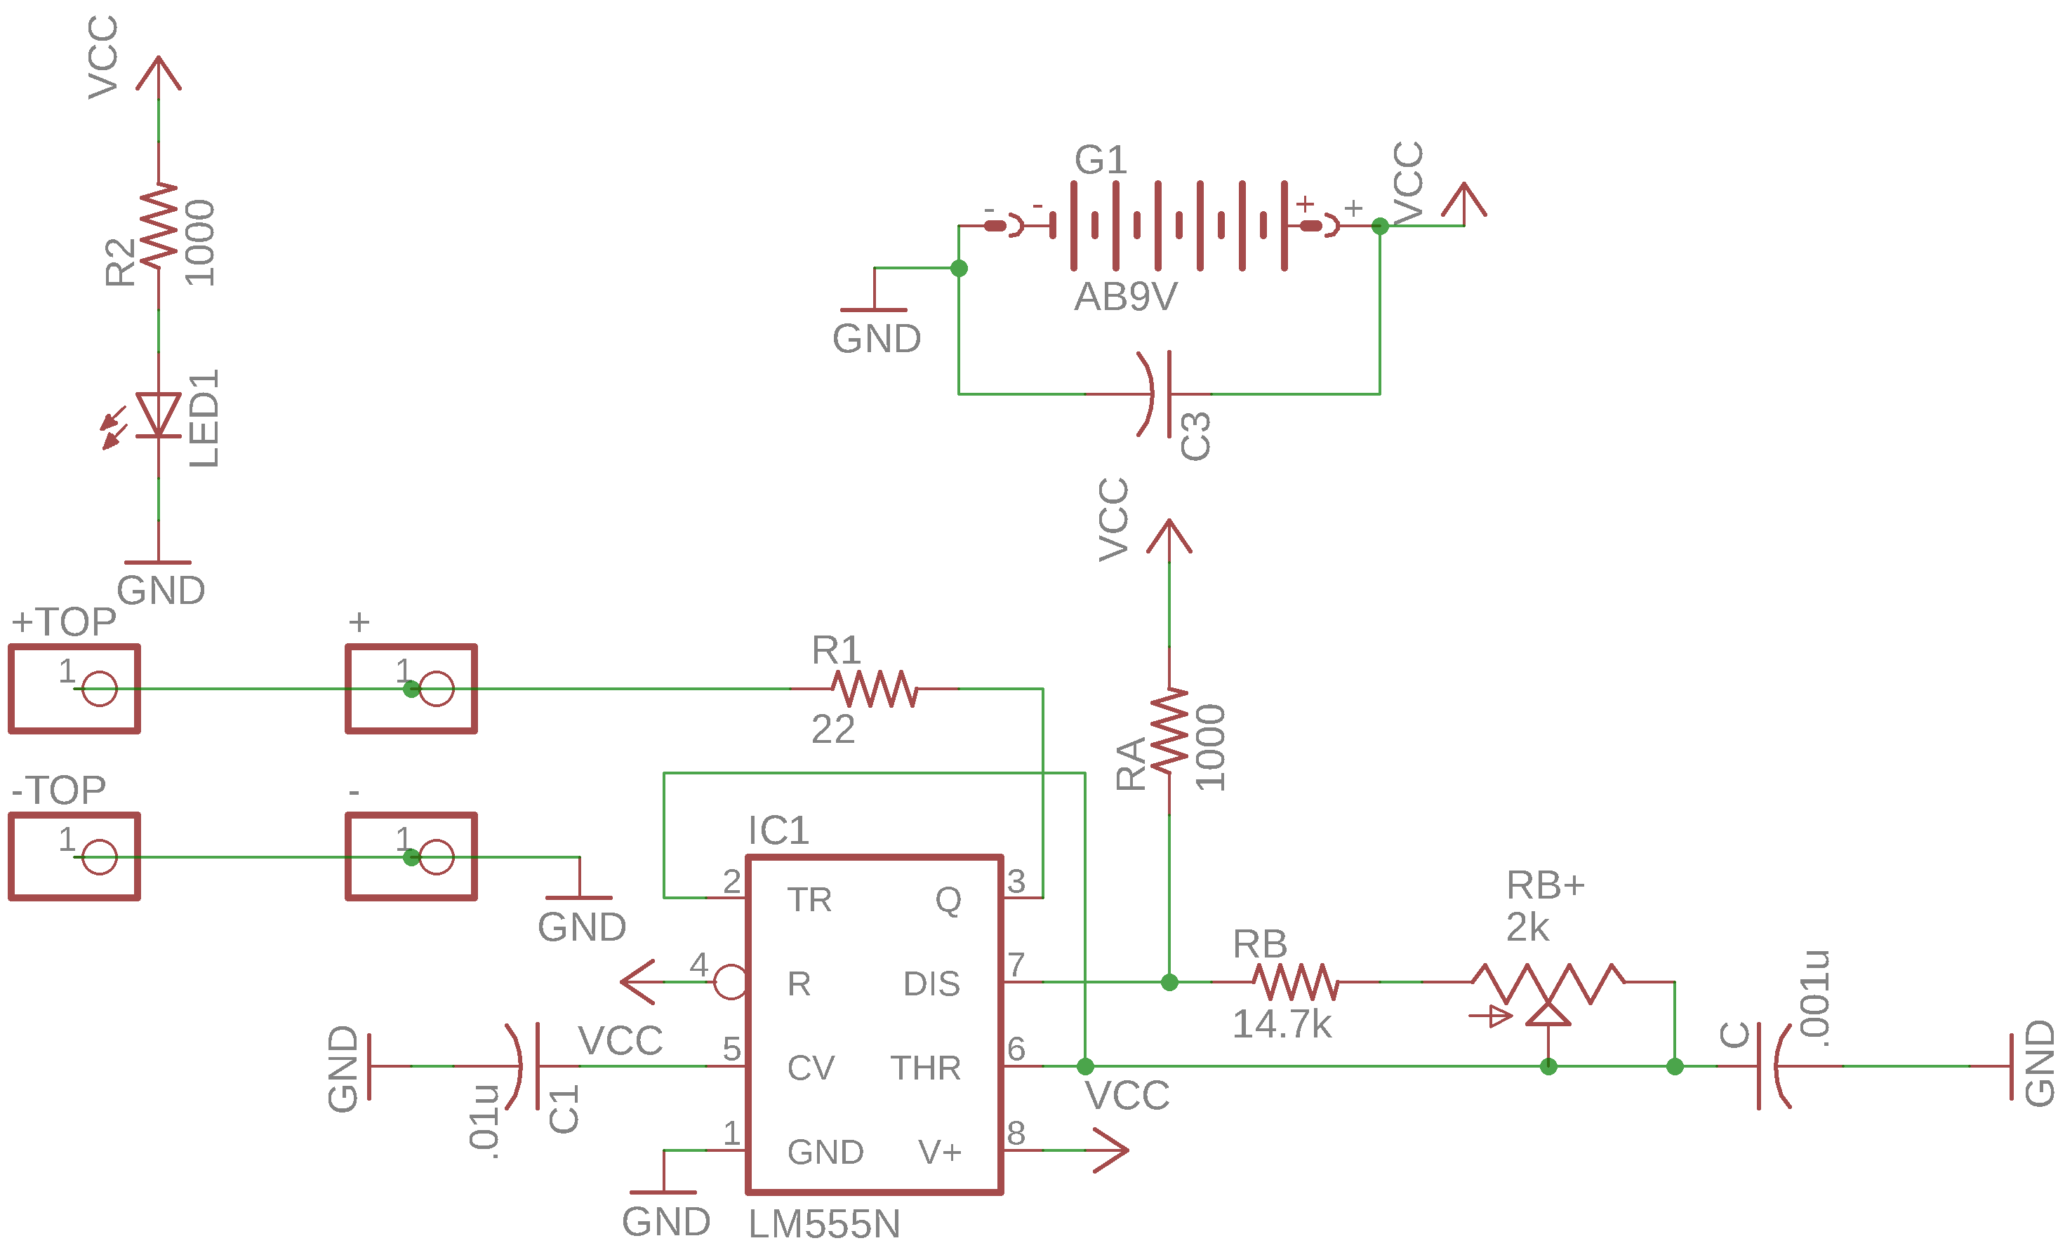

*Created with EagleCAD*